**Future Name Here**

**Requirements Specifications**



**Team RSS**

Jackson Schuur

Sophia Schuur

Kathy Freund

Austin Ryf

Course: CptS 322 - Software Engineering Principles I

Instructor: Sakire Arslan Ay

**TABLE OF CONTENTS**

I. Introduction 4

II. Requirements Specification 4

II.1. Customer, Users, and Stakeholders 4

II.2. User Stories 4

II.3. Non-Functional Requirements 5

III. User Interface Requirements 5

IV. References 5

Appendix: Grading Rubric 6

# Introduction

New parents often have a hard time connecting with other parents around the neighborhood. They are often stuck inside with their new babies and may have trouble getting out of the house due the demands of their children. Parents may not know where to find quick, easily accessible information.

Our app seeks to begin the basis of a platform that aids new parents into finding family friendly events around their neighborhood. The app will allow users to create a profile and will be able to post and search for activities in town. These may include, but are not limited to, neighborhood birthday parties, story times at local libraries, Play to Learn activities, or city clubs.

Section II includes basic functional requirements users of the app may participate in.

Section III includes a basic description of the graphical interface.

**Document Revision History**

Rev 1.0 10/8/2018 ­ Initial version

# Requirements Specification

Users will be able to create a profile in which they may choose a username and password, set their location, and set a family status (number of children, number of parents). They may subscribe to events or choose to drop from them. They may search for events to attend based on date, location, or age of other children. We may potentially include a search function to search for certain strings in an event title as well.

Users may post events for other users to view and RVSP to. They may include a title of the event, a location, a description, and who is hosting it (including themselves). They may set a limit on child age or number of attendees. They will be able to see which other users subscribe to their event.

While all users will can post events, it will likely occur that certain accounts associated with local business will host the majority of events where other residential users subscribe.

## Customer, Users, and Stakeholders

The primary target demographic encompasses families with young children. The primary use of this application is to offer a more convenient platform for said young families to conglomerate at various hosted events. Other parents, local libraries, schools, gyms, and other various organizations may host these events.

## Use Cases

All users can post events. Use cases will work very similarly to other websites in which a user may create an account and only that user can edit certain attributes of the account. All users may post or subscribe to events, but only the poster of a specific event can edit it. They must be logged in to do so. There will be two cases: an account that posts events at any given time, and an account that does not. These use cases may encompass the same account. Error conditions include but are not limited to entering the bounds of our title and description character limit.

**Use case # 1**

|  |  |
| --- | --- |
| Name | User Profile |
| Users | Parents, any event goer |
| Rationale | Anyone who wishes to view local events |
| Triggers | Desire to attend event |
| Preconditions | Anytime |
| Actions | Get |
| Postconditions | No change |
| Acceptance Tests | No change |
| Iteration | First |

**Use case # 2**

|  |  |
| --- | --- |
| Name | User Profile |
| Users | Parents, event hosting organizations, any event creator |
| Rationale | Anyone who wishes to create an event |
| Triggers | Desire to post a new event |
| Preconditions | Anytime |
| Actions | Post |
| Postconditions | New event to database |
| Acceptance Tests | If new event exists in database |
| Iteration | First |

## Non-Functional Requirements

1. Font: Incorporate and implement a creative common licensed or otherwise free licensed font
2. Color Scheme: Implement a youthful, yet easy-to-read color palette throughout the app
3. Design: Upon logging in, users will see the next 10-15 nearby events sorted by date posted
4. Commenting?: Users may comment on events

# User Interface Requirements

Our graphical interface is highly subject to change as we figure out we can and cannot do. For the basics, upon logging in, users will see a large feed displaying the next 10 or so nearby events organized by date. They will see the event title, location, and a description at the bottom of each event with a certain character limit, in order to preserve space for other events.

There will be an area in the upper left corner to search for events.

There will be a column to the right side that will show a feed of a user’s subscribed events, also organized by date.

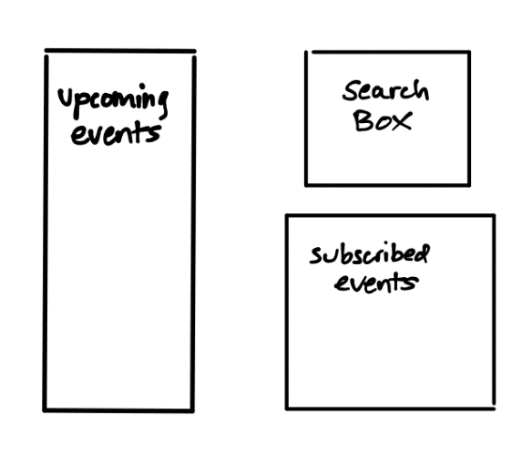

# 

# Here is a potential very basic design of the user interface upon logging in.

# References

Our own team group background knowledge